|  |
| --- |
| 232119900013 |
| 232119900014 |
| 232119900015 |
| 卡座 |
| （体育馆二楼） |

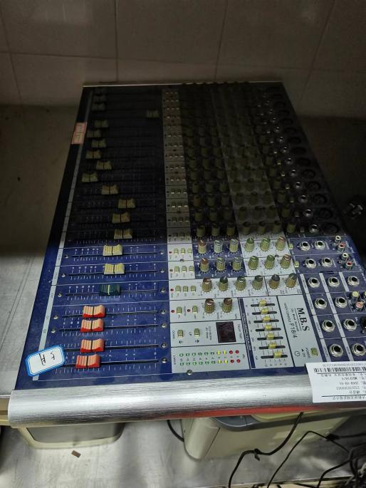 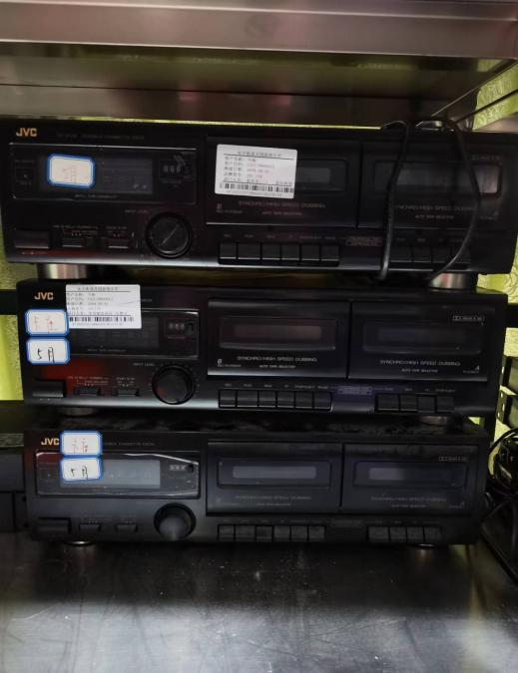

232030200003调音台（体育馆二楼）

|  |
| --- |
| 231070300001 |
| 231070300003 |
| 231070300004 |
| 231070300005  交换机  （体育馆二楼） |

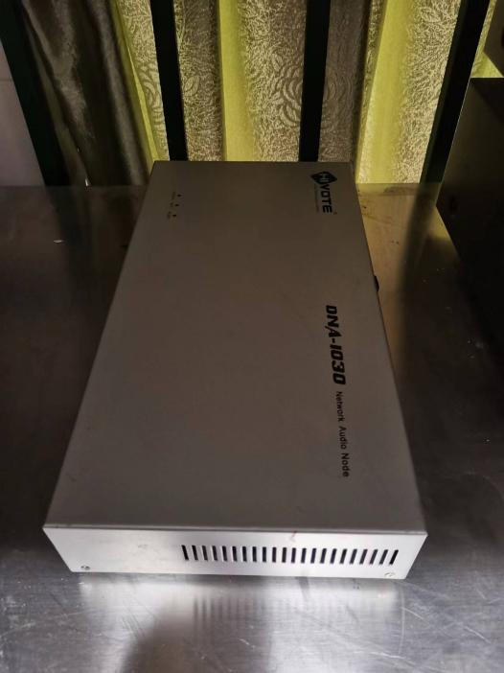 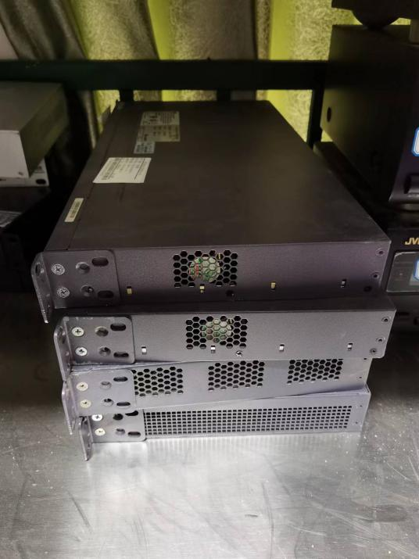

|  |  |
| --- | --- |
| 232990000019 音频受控节点  （体育馆二楼） |  |

|  |
| --- |
| 232110600003 |
| 232110600011 |
| 232019900003 |
| 无线唛 |
| （体育馆二楼） |

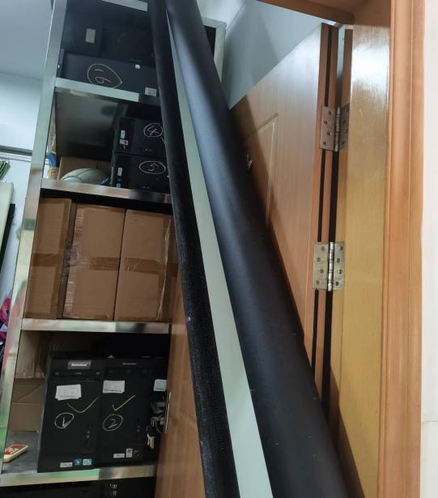 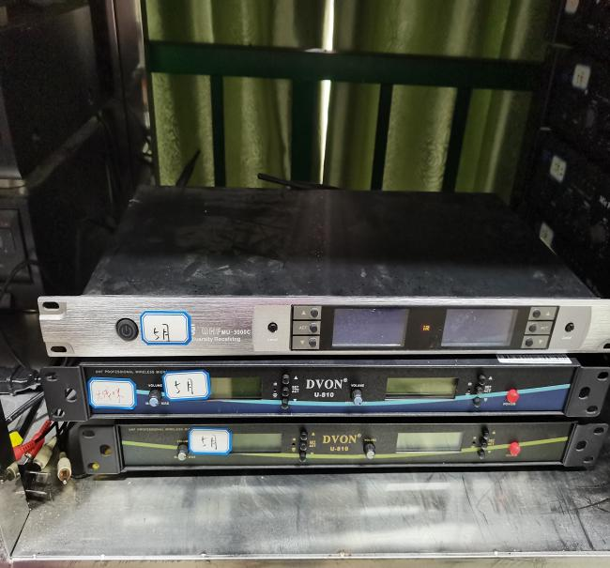

|  |  |
| --- | --- |
| 202990000111 | 电动屏幕 |
| （体育馆二楼） |  |

|  |  |
| --- | --- |
| 232110300071 |  |
| 232110300074 |  |
| 232110300080 |  |
| 232110300087 |  |
| 232110300109 |  |
| 232110300112 |  |
| 202990000029 |  |
| 202990000065 | 中控 |
| 202990000073 | （体育馆二楼） |
| 202990000086 |  |
| 202990000118 |  |
| 202990000129 |  |
| 232110300009 |  |
| 202990000037 |  |
| 202990000068 |  |
| 202990000080 |  |
| 202990000113 |  |
| 232110300014 |  |

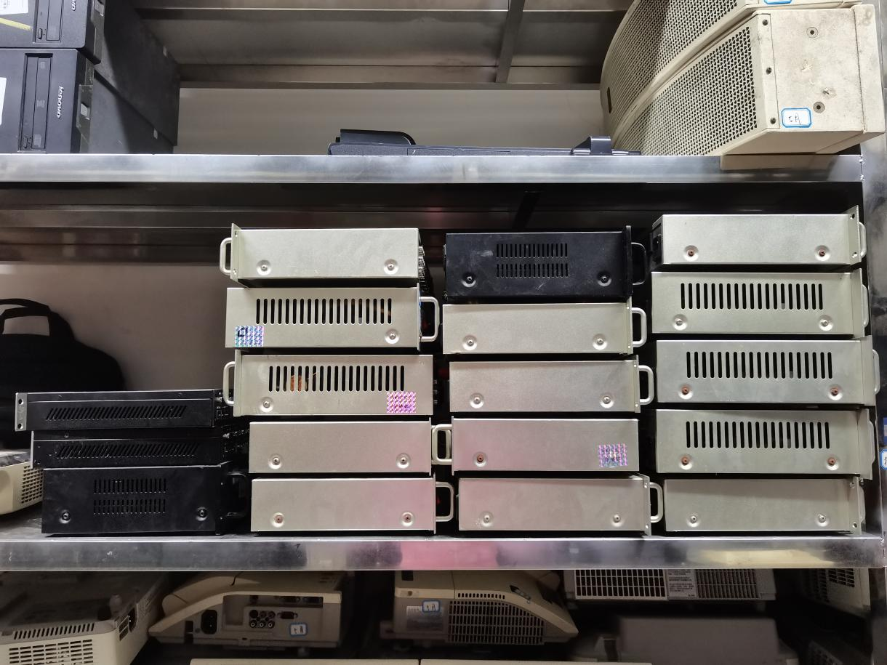

|  |  |
| --- | --- |
| 232110300021 |  |
| 232110300022 |  |
| 232110300043 |  |
| 232110300057 |  |
| 232110300063 |  |
| 232110300077 |  |
| 232110300089 |  |
| 232110300095 | 功放 |
| 232110300104 | （体育馆二楼） |
| 232110300106 |  |
| 232110300116 |  |
| 232110300123 |  |
| 232110300124 |  |
| 232110300125 |  |
| 202990000072 |  |
| 202990000083 |  |
| 202990000099 |  |
| 232110300001 |  |

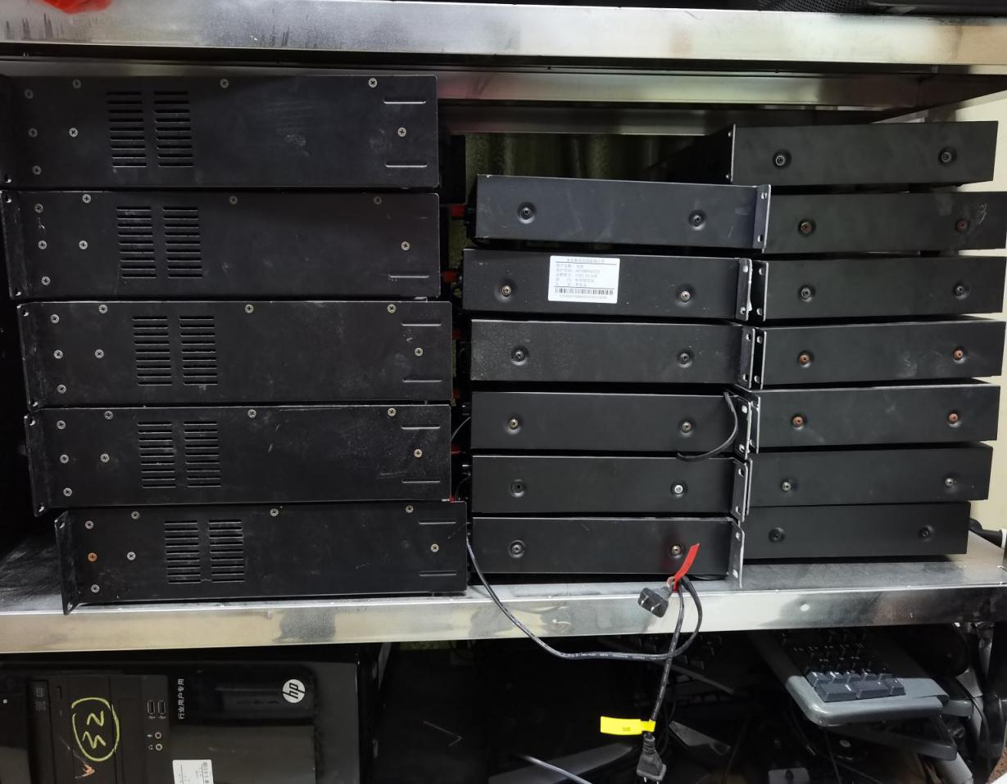

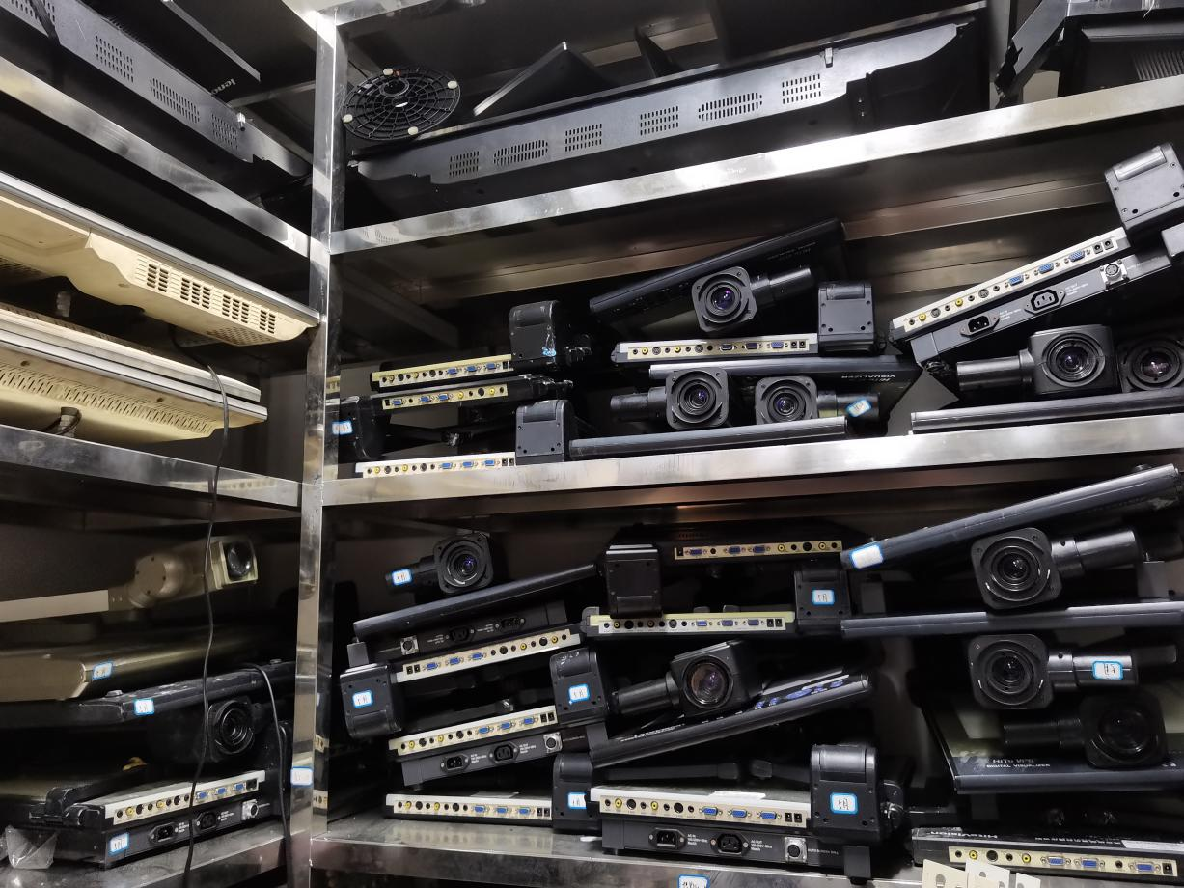

|  |  |  |  |  |
| --- | --- | --- | --- | --- |
| 232110300019 | 232110300018 | 232109900006 | 232110300099 |  |
| 232110300069 | 232110300037 | 232109900007 | 232110300105 | 展台 |
| 202990000030 | 232110300052 | 232109900014 | 232110300113 | （体育馆二楼） |
| 202990000063 | 232110300061 | 232110300008 | 202990000021 |  |
| 202990000090 | 232110300064 | 202990000117 | 202990000049 |  |
| 202990000091 | 232110300082 | 202990000127 | 202990000059 |  |
| 232109900004 | 232110300093 | 232110300002 | 202990000108 |  |
|  |  |  |  |  |

|  |  |
| --- | --- |
| 232110300078 |  |
| 232111000001 |  |
| 232119900010 | 音箱 |
| 202990000047 | （体育馆二楼） |
| 202990000077 |  |
| 202990000093 |  |

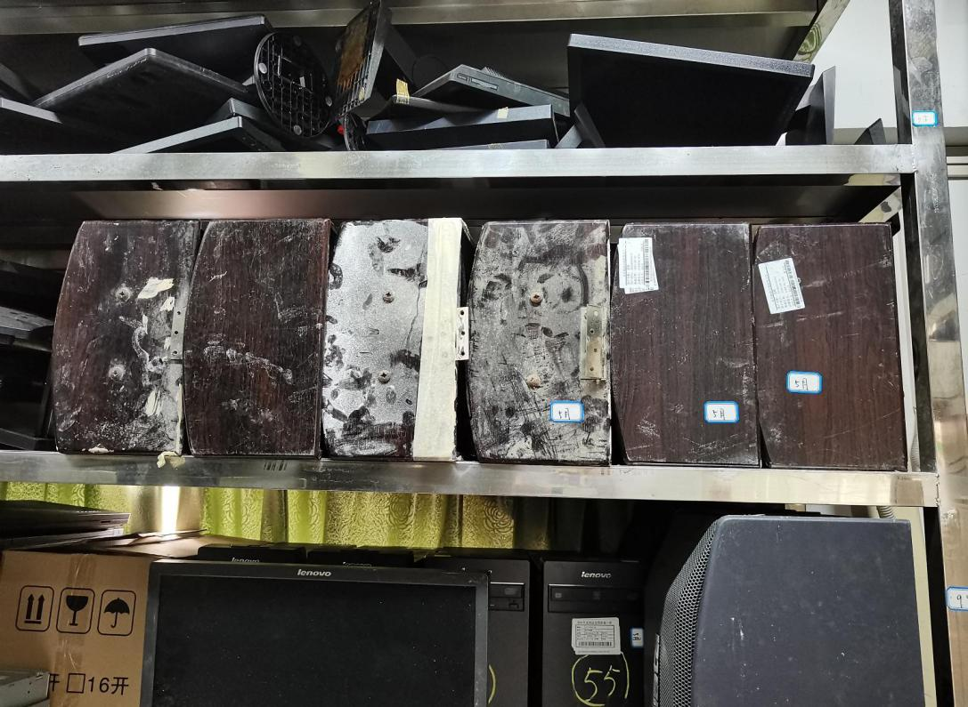

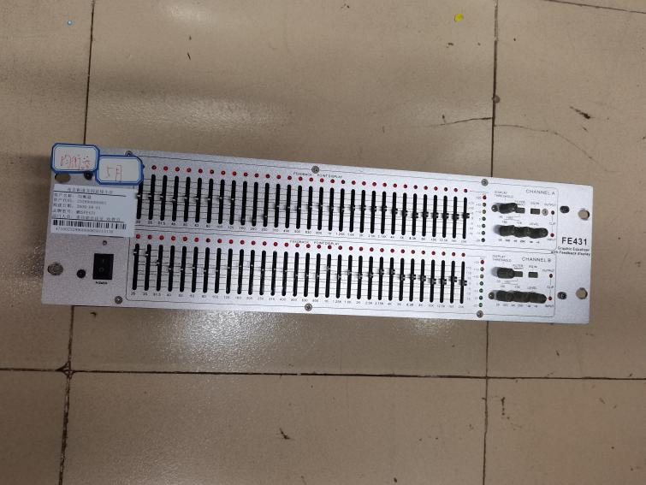 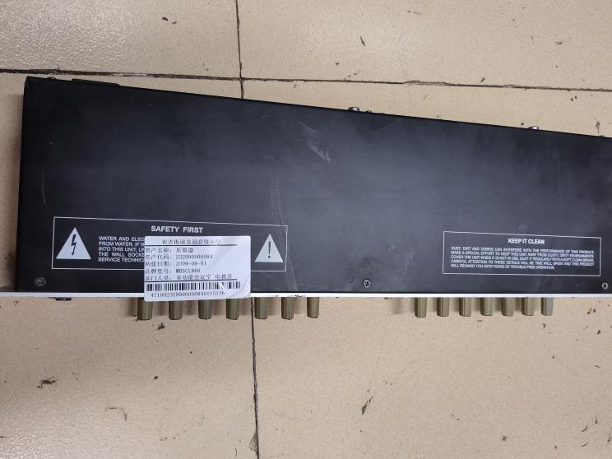

|  |  |  |
| --- | --- | --- |
| 232990000083 | 均衡器 | （体育馆二楼） |

|  |  |  |
| --- | --- | --- |
| 232990000084 | 压限器 | （体育馆二楼） |

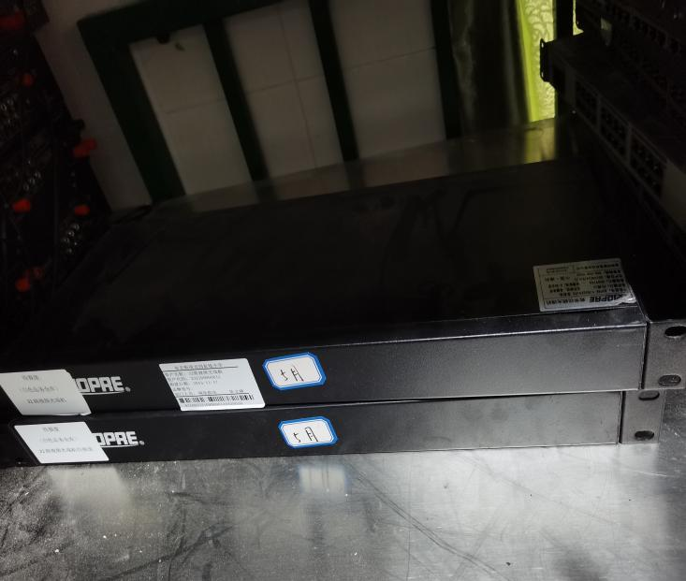 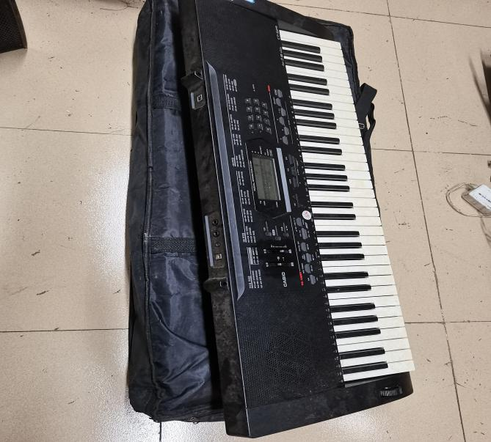

|  |  |
| --- | --- |
| 232109900010 | 32路视频光端机 |
| 232109900011 | （体育馆二楼） |

|  |  |
| --- | --- |
| 370010400003 | 电子琴 |
| 370010400007 | （体育馆二楼） |

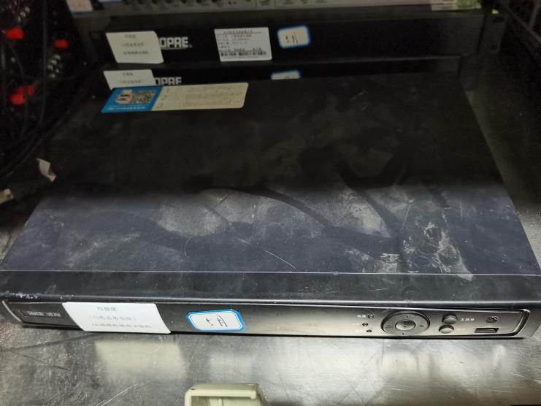 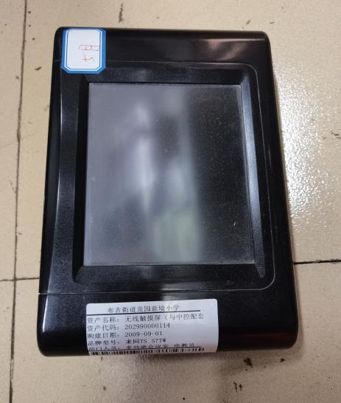

|  |  |  |
| --- | --- | --- |
| 327049900039 | 模拟硬盘录像机 | （体育馆二楼） |

|  |  |  |
| --- | --- | --- |
| 202990000114 | 无线触摸屏  （与中控配套使用） | （体育馆二楼） |

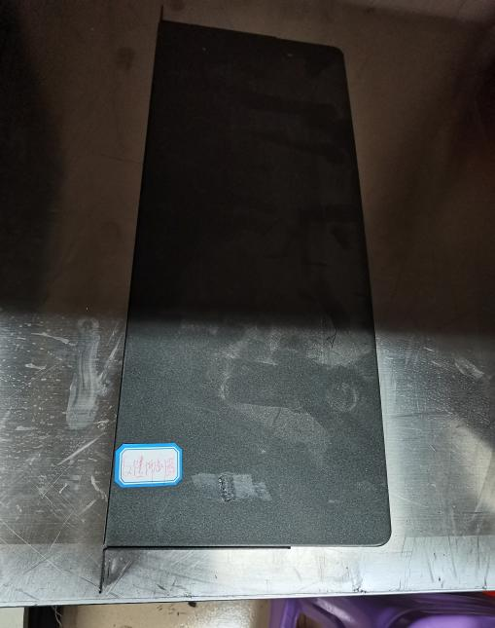 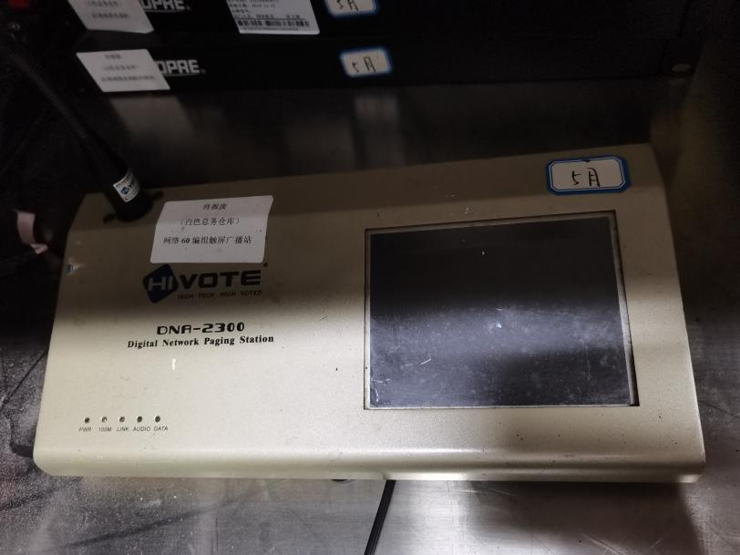

|  |  |
| --- | --- |
| 232990000087 | 反馈抑制器 |
| （体育馆二楼） |  |

|  |  |  |
| --- | --- | --- |
| 232990000088 | 网络60编组触屏广播站 | （体育馆二楼） |

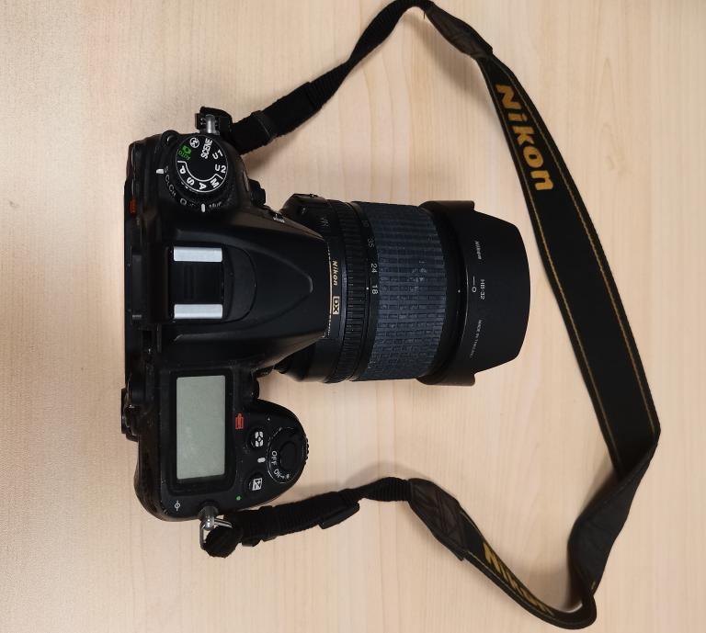 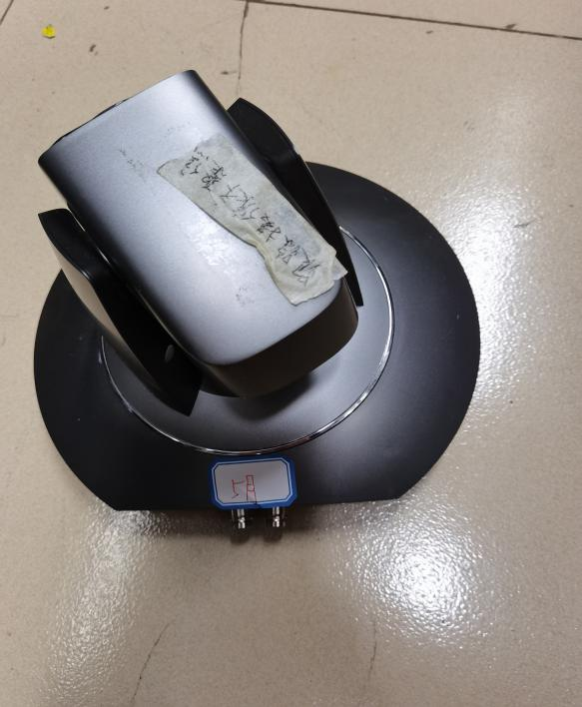

|  |  |  |
| --- | --- | --- |
| 202040000011 | 尼康1620万像素数码单反相机 | （体育馆二楼） |

|  |  |  |
| --- | --- | --- |
| 232049900011 | 学生自动定位  高清摄像机 | （体育馆二楼） |

|  |  |
| --- | --- |
| 601079900007 | 风机 |
| 601079900013 | （体育馆二楼） |

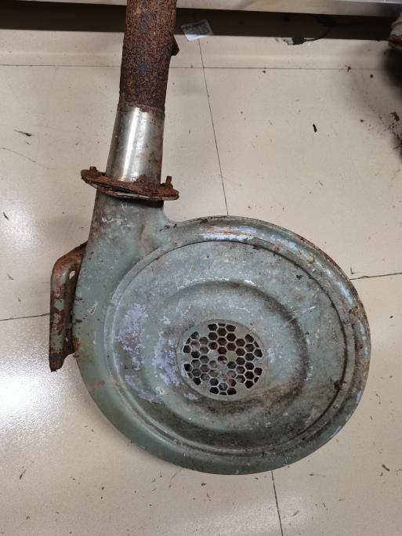 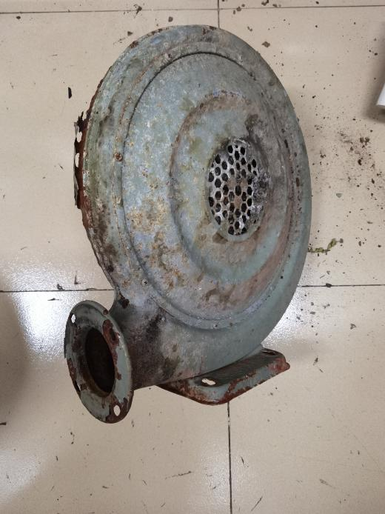

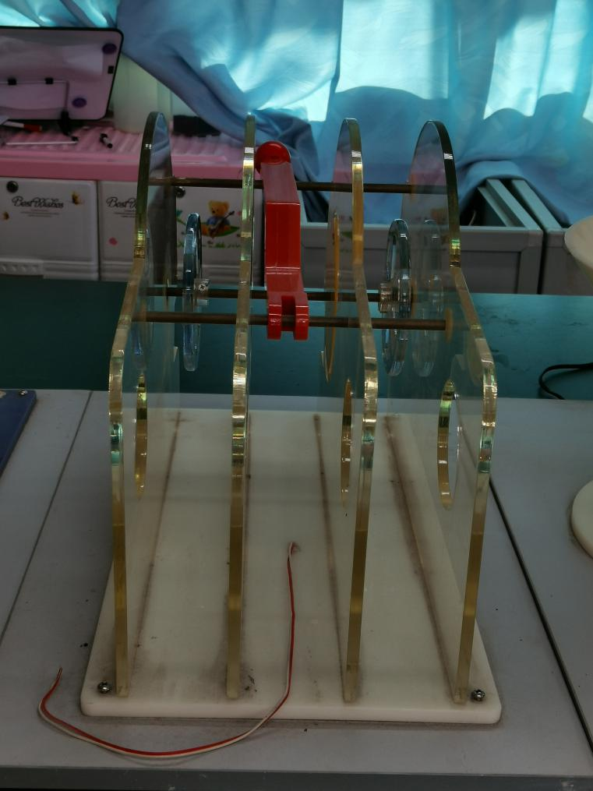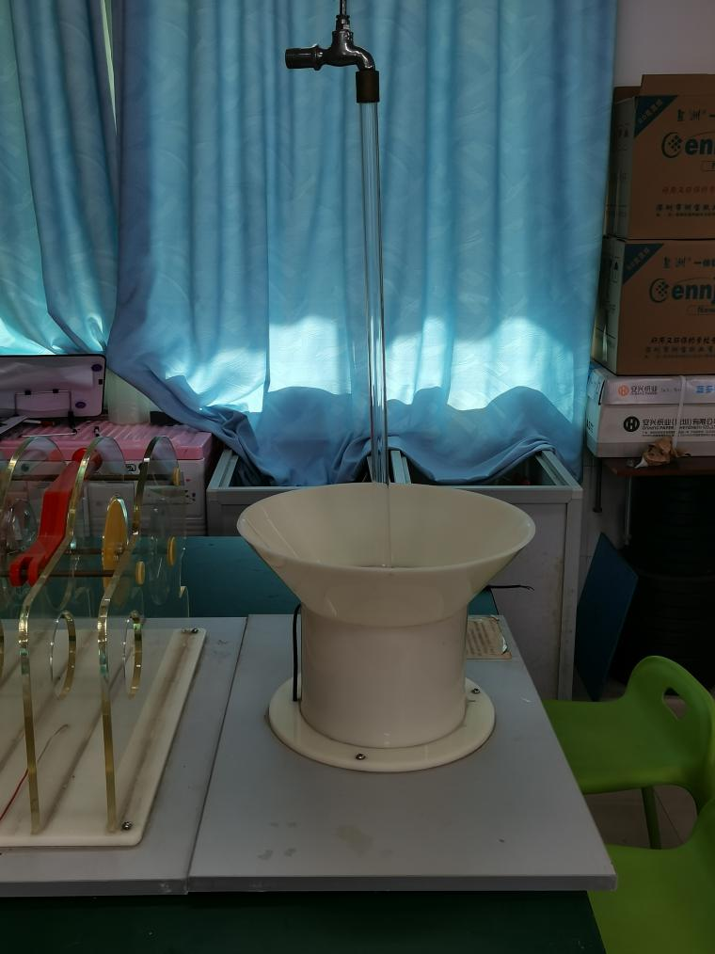

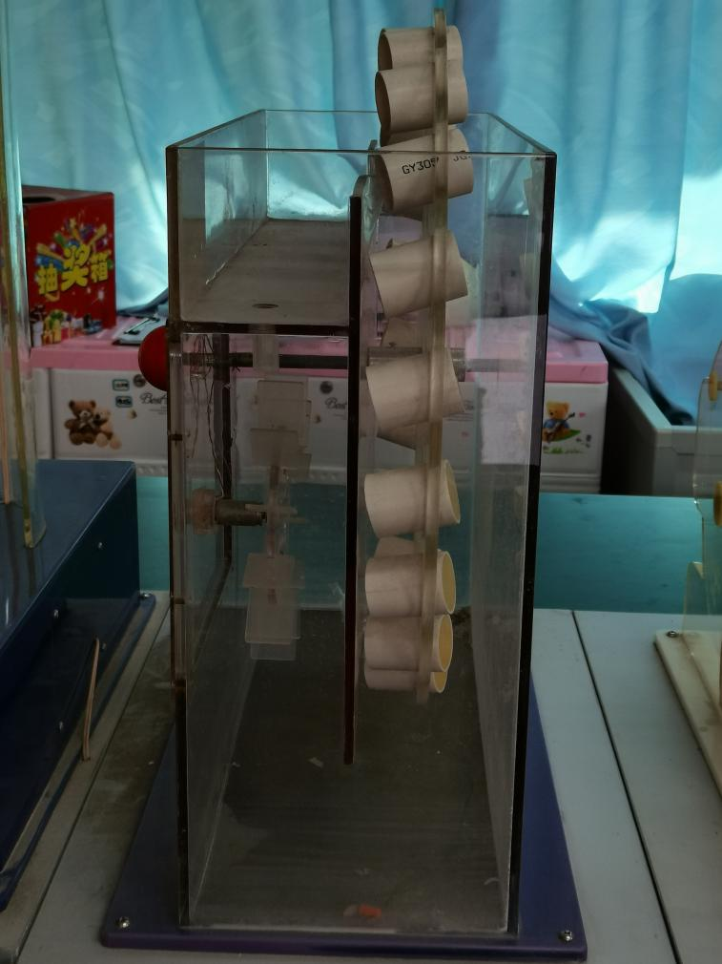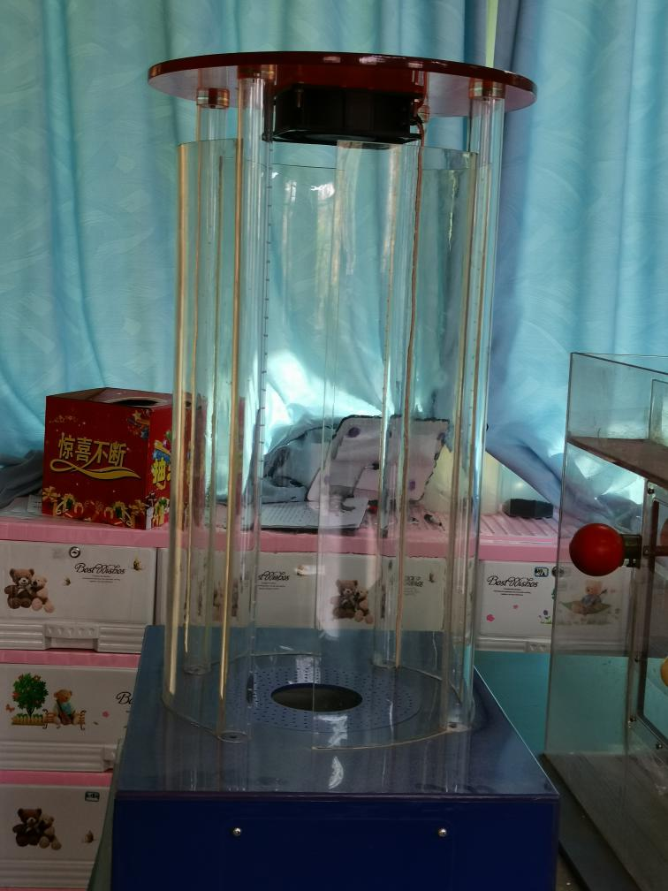

|  |  |  |
| --- | --- | --- |
| 360080200002 | 360990000001 | 科学原理演示 |
| 360099900001 | 360990000002 | （操场集装箱） |
|  |  |  |
|  |  |  |
|  |  |  |

|  |
| --- |
| 202020000011 |
| 202020000023 |
| 202020000029 |
| 202020000035 |
| 202020000037 |
| 202020000038 |
| 202020000039 |
| 202020000040 |
| 202020000041 |
| 202020000042 |
| 202020000043 |
| 202020000044 |
| 202020000045 |
| 240030300002 |
| 202020000046 |
| 202020000047 |
| 202020000048 |
| 202020000049 |
| 202020000050 |
| 202020000051 |
| 202020000052 |
| 202020000053 |
| 202990000038 |
| 投影仪 |
| （体育馆二楼） |

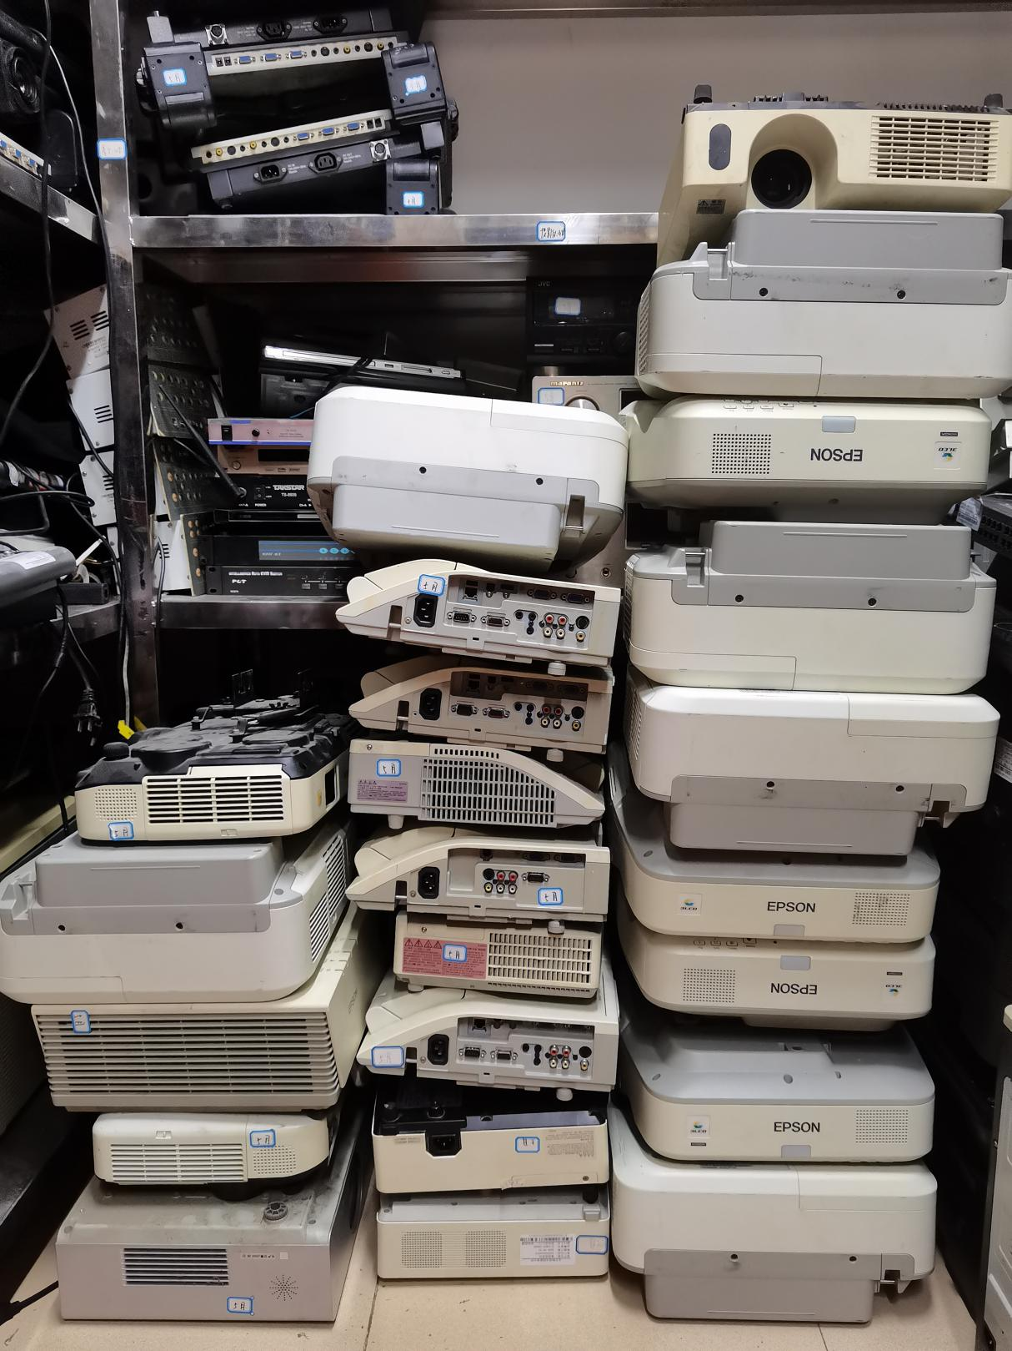

|  |  |  |
| --- | --- | --- |
| 201990000011 | 查询终端 | （操场白色板房里） |
| 201990000013 |  |  |

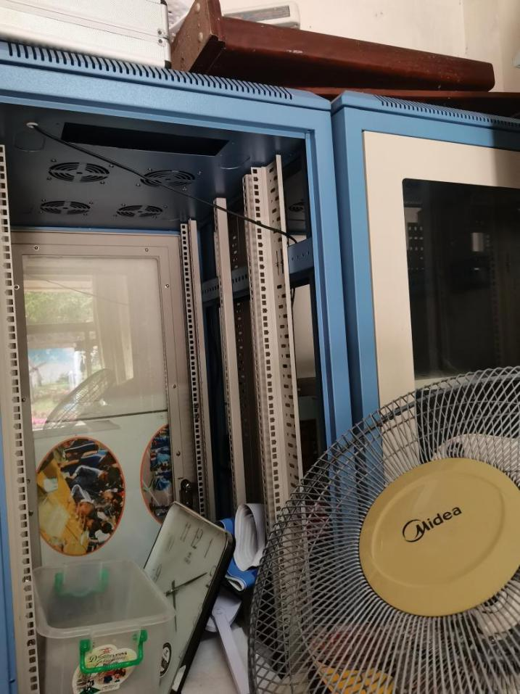 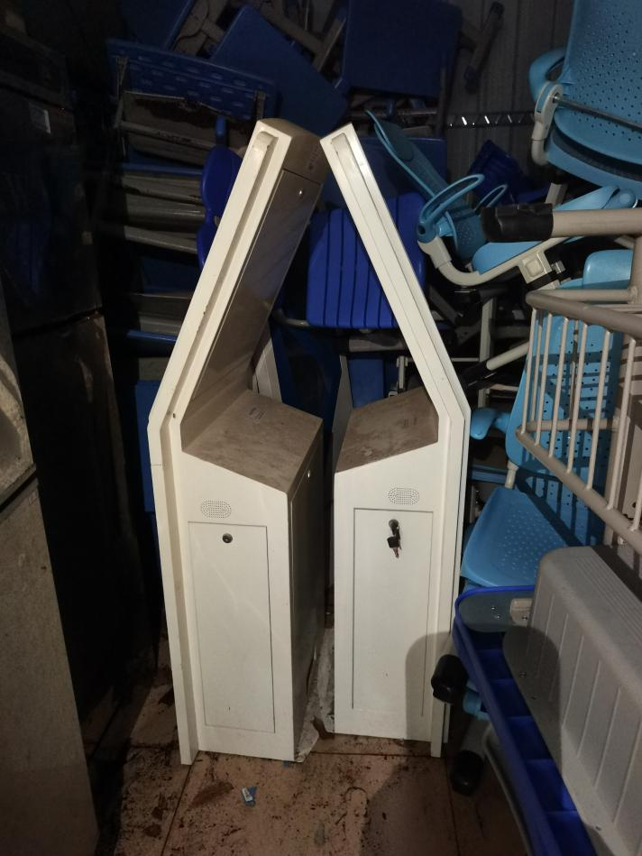

|  |  |
| --- | --- |
| 201029900003 | 42U机柜 |
| 201029900006 | （保安宿舍） |

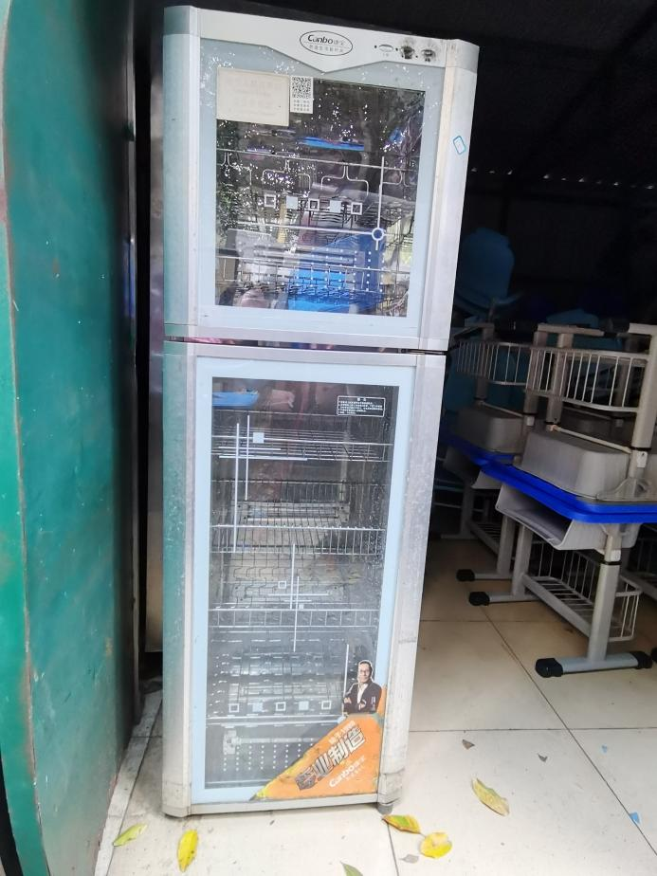 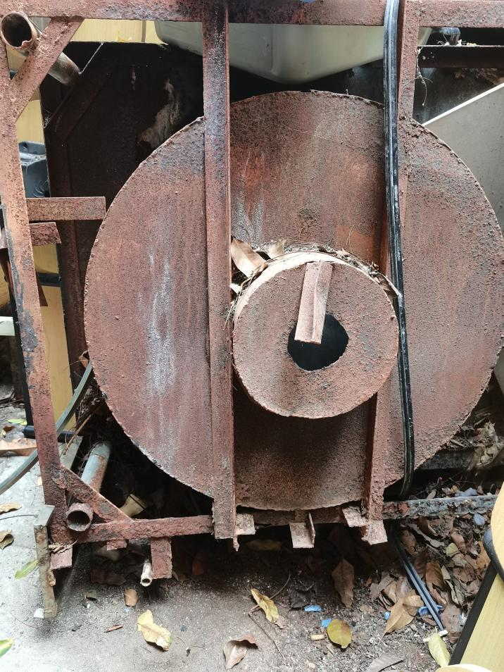

|  |  |  |
| --- | --- | --- |
| 314100000002 | 单小炒连中炒炉 | （操场白色板房旁） |

|  |  |  |
| --- | --- | --- |
| 314060000002 | 钢二门消毒柜 | （操场白色板房里） |

|  |  |
| --- | --- |
| 232110300053 | 202050000013 |
| 232110300118 | 202050000015 |
| 202050000001 | 202050000016 |
| 202050000002 | 202050000017 |
| 202050000004 | 202050000019 |
| 202050000005 | 202050000022 |
| 202050000006 | 202050000027 |
| 202050000009 | 202050000029 |
| 202050000010 | 202050000024 |
| 202050000012 |  |
| 白板 | (操场集装箱旁） |
|  |  |
|  |  |
|  |  |
|  |  |
|  |  |
|  |  |
|  |  |
|  |  |

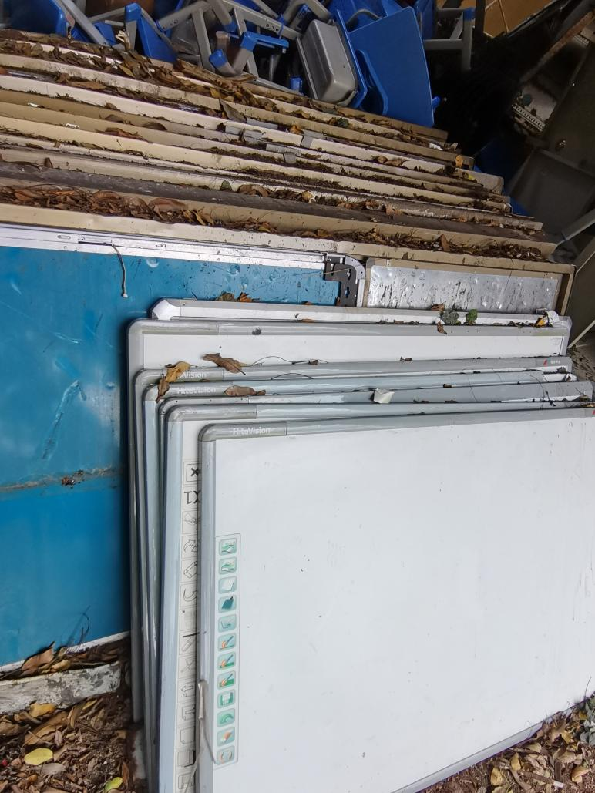

|  |  |
| --- | --- |
| 232110300067 | 202990000084 |
| 202990000019 | 202990000094 |
| 202990000039 | 202990000095 |
| 202990000042 | 202990000096 |
| 202990000043 | 202990000100 |
| 202990000046 | 202990000106 |
| 202990000050 | 202990000120 |
| 202990000057 | 202990000125 |
| 202990000076 | 多功能讲台 |
| （操场集装箱旁） | |
| 备注：其中有7件是木制讲台，露天存放风吹雨淋已腐烂 | |

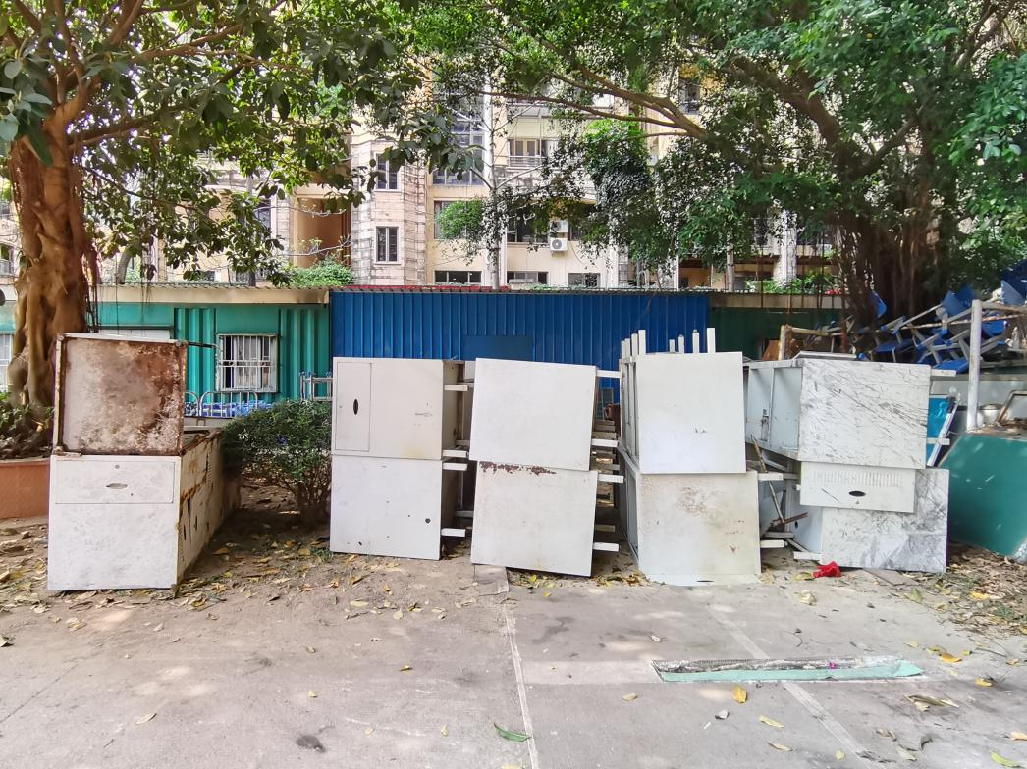

|  |  |
| --- | --- |
| 202990000023 | 202990000101 |
| 202990000027 | 202990000103 |
| 202990000033 | 202990000104 |
| 202990000040 | 202990000105 |
| 202990000052 | 202990000109 |
| 202990000056 | 202990000110 |
| 202990000062 | 202990000119 |
| 202990000085 | 推拉板 |
| 202990000088 | （操场集装箱旁） |

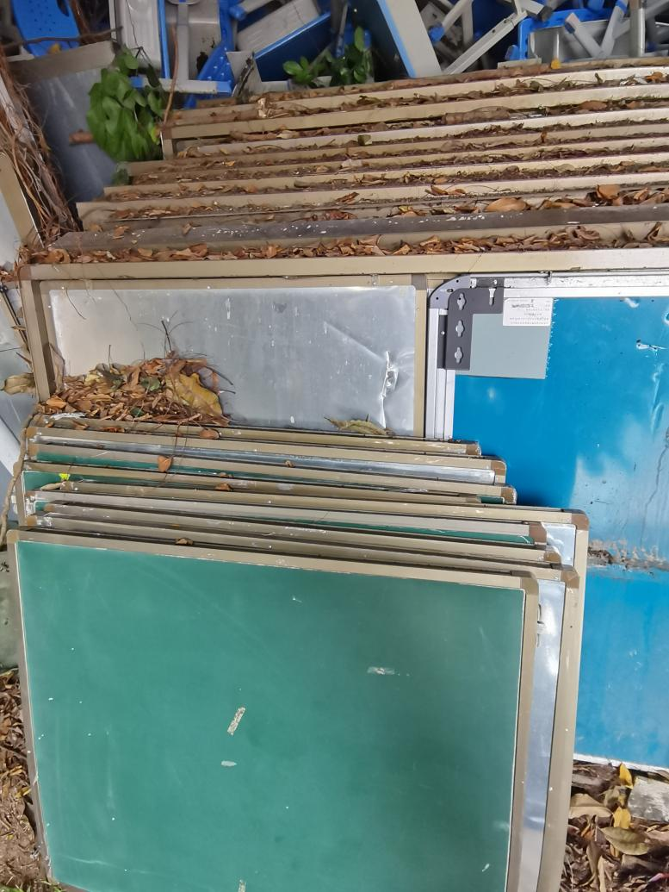

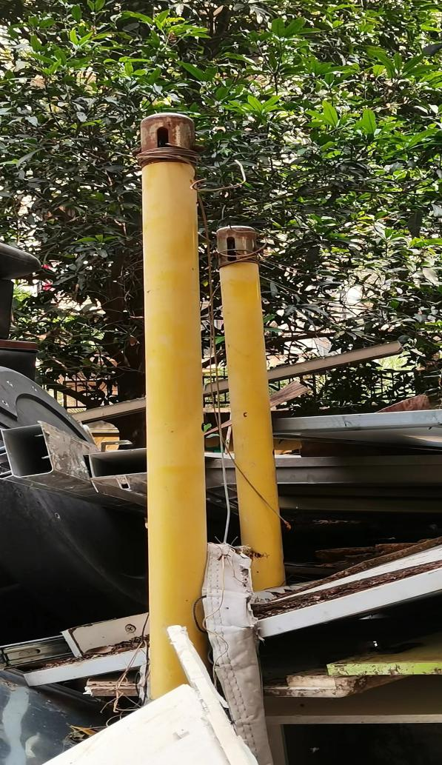 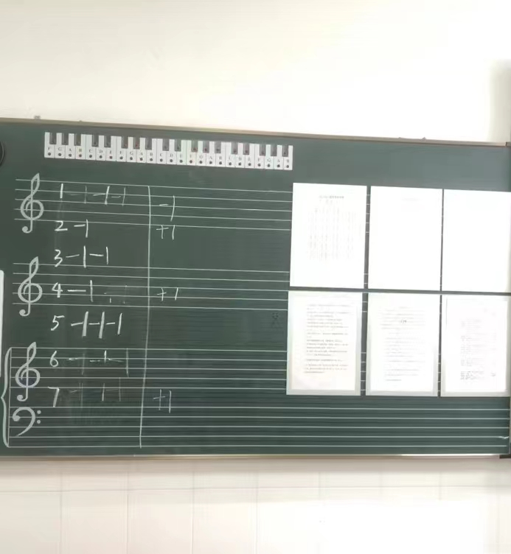

|  |  |  |
| --- | --- | --- |
| 371030300001 | 小型排球架 | （操场集装箱旁） |

|  |  |  |  |
| --- | --- | --- | --- |
| 202990000035 | 五线谱示教板 | （操场集装箱旁） |  |
|  |  |  |  |